Operational guide to VDAP analog seismic response

A brief guide to building response files in Seisan and StationXML format

Andy Lockhart

July 18, 2021

Contents

The basic response equation for the VDAP analog SP seismic system 3

Example: 6

Displacement response vs velocity response. 7

‘Sensor response’ and ‘datalogger response’ in StationXML formulation 8

Poles and Zeros formulation for the basic analog SP seismic system 9

Seismometer poles and zeros 9

4th order low-pass Butterworth filter poles and zeros 10

Normalization constant 11

Example of Seisan frequency and phase response representation 11

StationXML file construction 11

Seisan MULPLT processing of station PUS, GSE2 response and Seiscomp StationXML responses, compared. 12

Appendix 1. measuring the fundamental SP seismometer characteristics, Damping (B) and Motor Constant (G) 14

Appendix 2: Seisan Frequency and Phase (FAP) velocity response output, station PUS example 18

Appendix 3: Seisan Frequency and Phase (FAP) Displacement response output, station PUS example 20

# The basic response equation for the VDAP analog SP seismic system

One formulation of the equation describing the response of the USGS/VDAP short-period analog telemetered seismic network through the digitizer output *V(f)* (V/m/sec) is:

***V(f)=******Tvv(f)*Ge*McVCOGain*VCOlopass4 *McVCOFreq*DiscFreq*DiscLopass4*ADC***

Since the displacement Z(f) is just the velocity multiplied by 2*π*f(hz),

**Z(f)= 2*π*f(hz)* *Tvv(f)*Ge*McVCOGain*VCOlopass4 *McVCOV-Freq*DiscFreq-V*DiscLopass4*ADC***

Where:

*Ge* is the sensor effective motor constant calculated at the McVCO preamp (V/m/sec)

$$Ge=G*\frac{Rs*Ramp}{\left(Rseis+Rt\right)*\left(Rs+Ramp\right)+(Rs*Ramp)}$$

where

*G*= seismometer motor constant (v/m/sec)

*Rt*=series resistance of the VCO L-pad (ohms)

*Rs*=parallel resistance of the VCO L-pad (ohms)

*Ramp*=input impedance of the VCO preamp, U1 (ohms)

*Rseis*=resistance of the seismometer coil (ohms)

$T_{v}^{v}$ (ω)=velocity response function of the velocity transducer (the geophone) (sec-1)

1

as per Havskov and Alguacil (2004), equation (2.36)

$$T_{v}^{v}(f)=\frac{f^{2}}{f_{0}^{2}-f^{2}+2iβf_{0}f}$$

Note that the value of Tvv(f) is the same as Tvv(*ω)*.

$$T_{v}^{v}(ω)=\frac{ω^{2}}{ω_{0}^{2}-ω^{2}+2iβω_{0}ω}$$

Where:

*f* = frequency (hz)

*f0* = characteristic frequency (hz)

*ω* = frequency (rad/sec) (=2πf)

*ω 0* = characteristic frequency of seismometer (rad/sec) (= 2πf0)

*β* = damping

*= β 0+ β 1*

Where

*β 0*=mechanical damping of geophone

*β 1*=electromagnetic damping of geophone



2

Where:

*M*=seismometer mass (kg)

*G*= seismometer motor constant (Note: this is the motor constant value inherent to the seismometer and given in the seismometer parameters from the factory, not the effective motor constant (Geff) calculated as above that takes the L-pad and amplifier resistances into account) (v/m/sec)

*Rt*=series resistance of the VCO L-pad (ohms)

*Rs*=parallel resistance of the VCO L-pad (ohms)

*Ramp*=input impedance of the VCO preamp, U1 (ohms)

*Rseis*=resistance of the seismometer coil (ohms)

*McVCOGain*=gain of the McVCO. As formulated here, Gain is not in dB. Convert the McVCO gain setting(dB) to gain by dividing it by 20 and raising 10 to that power.

(ie 60dB =103=1000, also, 72dB= 1072/20=103.6=3981)

*McVCO_V_freq(Hz/V)*=the VCO volt to frequency conversion, 115Hz/4.05V, or 28.5Hz/V.

*Disc_Freq_V(V/Hz)* = the discriminator frequency to volt conversion, 2.5V/125Hz, or 0.02V/Hz.

The odd McVCO voltage to frequency conversion, 115Hz/4.05V is the legacy of an obsolete USGS VCO design that used 4.05V mercury dry cells for power and voltage reference. Subsequent USGS VCOs and the VDAP McVCO still use this conversion for backward compatibility. Other institutions use a voltage to frequency conversion that matches the discriminator, for a net zero effect on system gain. Due to the legacy value of McVCO_V_Freq, there is a net reduction in gain through the McVCO voltage to frequency conversion and the discriminator frequency to voltage conversion of

28.5V/Hz*0.02Hz/V, or

0.569, or

-4.9dB. This value is added to the McVCO gain in dB for the total system gain.

Note that the McVCO and discriminator V/Freq and Freq/V conversion factors can be measured and should be adjusted for accurate gain estimates. See the McVCO handbook and the discriminator handbook for details.

McVCO and the discriminator each have 4th order low-pass Butterworth filters. The McVCO filter center frequency is 30Hz, The J120 or Mc8 discriminator filters both have a 20Hz center frequency.

The general equation for a low pass Butterworth filter response (see for example Havskov and Alguacil eqn 6.61) can be represented as:1

Where:

ω = frequency (rad/sec) = 2*π* f(hz)

ωc = filter center frequency (rad/sec) = 2*π*fc

*f* = frequency (Hz)

*fc* = corner frequency of McVCO low-pass filter, 30Hz

n = order of the filter

In Excel notation, 4th order McVCOlopass (at f=1Hz) =(1/((1+(f/30)^(8)^0.5)) = 1.00

In Excel notation, 4th order DiscLopass (at f=1Hz) =(1/((1+(f/20)^8)^0.5)) = 1.00

Note that the filter response equations are equivalent for f(hz) and ω(rad/sec), where ω=2πf.

Note also that the filter response for each of these at the corner frequency is 0.707, or 1/(2^.5).

*ADC*= analog/digital converter factor, in ADC counts/volt.

For the USGS/VDAP Earthworm installations that use the National Instruments PC-MIO-16E-4 analog-digital converter, *ADC* is 819.2ct/v

For Earthworm systems using the PSN analog-digital converter, *ADC*= 6554 ct/v, if the ADC range is selected as +/-5V.

In the response equation notation used by the Seisan program RESP.EXE,

Amplifier Gain = McVCOGain*McVCO_V_Freq*Disc_Freq_V, in dB

Recording Media Gain=ADC, in ct/V.

### Example:

Here are some standard values of parameters. These parameters are taken from station PUS in Indonesia, provided by Sulistiyani

Seismometer: Sercel (Mark) L-4

f0 = center frequency = 1.0Hz

f0 is fixed by the manufacturing. It can drift through time but can be measured by the procedure in Appendix 1.

β = damping coefficient = 0.8

β is set in part by the seismometer and in part by the resistor network (the ‘L-pad’) matching it to the McVCO. See Appendix 1.

Ge = effective motor constant = 100 V/m/sec

Ge is set by the seismometer and the resistor network, like the damping. See Appendix 1

Tvv(f) = The seismometer velocity transfer function (sec-1)

In Excel notation, Tvv(f) =((f^2)/(f0^2-f^2+2*damping*f0*f)

=0.652

VCO: USGS/VDAP- configured McVCO

McVCOGain = McVCO gain in dB = 72dB = 3981 v/v

Gain is set by the McVCO switches in dB, or 10^(gain/20)

McVCO_V_Freq =28.5Hz/V (see above)

McVCO 4th-order low-pass Butterworth filter frequency =30Hz; gain at 1Hz =1

Discriminator: USGS J120 or VDAP Mc8

Discriminator 4th-order low-pass Butterworth filter frequency = 20Hz; gain at 1Hz =1

Disc_Freq_V = 0.02V/Hz

Combining McVCO_V_Freq and DiscFreq_V as above, ‘gain’ through the McVCO-Discriminator

= 0.568v/v

= -4.9dB.

For the example of station PUS with McVCOgain=72dB and McVCO_V_Freq * Disc_Freq_V = -4.9dB

Gain = 72-4.9dB = 67.1dB = 2261v/v

ADC: There are three common ADCs in use

1. National Instruments: is 12bit; 4096 over 10V x gain of 2 = 819.2ct/V
2. PSN is 16bit; 65536/10V range = 6553.6 ct/V
3. Guralp 16R (BPPTK) is 16 bit /20V range or 3276.8ct/V

The equation for total system gain at a frequency is

V(f)ct/m/sec=Tvv(f)(V/V)*Ge(v/m/sec)*McVCO_Gain(V/V)*McVCOLoPass(f)(V/V)*McVCO_V_Freq(Hz/V)*DiscrimLoPass(f)(V/V)*Disc_Freq_V(V/Hz)*ADCct/V

And the units are ct/m/sec. This is the ***velocity*** response.

The example values are:

Tvv(f) =0.625

Ge = 100V/m/sec

McVCOgain = 3981v/v

McVCO_V_Freq*Disc_Freq_V= 0.568v/v

McVCOlopass (1Hz) =1.00

DiscLopass(1Hz) = 1.00

ADC (Guralp 16R) = 3276.8ct/V

Using the example values for station PUS At 1 Hz, the ***velocity*** response V(f):

V(1Hz) = 0.625*100v/m/sec*3981*1.00*0.568*1.00*3276.8ct/V = 4.63E+8ct/m/sec

The ***displacement*** response Z(f) is just 2*π*V(f), or 2.91E+09 ct/m

### Displacement response vs velocity response.

Seisan requires a displacement response (three zeros in the seismometer PAZ response). The StationXML is a velocity response (two zeros in the seismometer PAZ representation)

The displacement response amplitude is simply the velocity response times ω, or 2*π*f, or with a third zero in the PAZ representation, where the velocity response has two.

### ‘Sensor response’ and ‘datalogger response’ in StationXML formulation

StationXML distinguishes ‘sensor response’ from ‘datalogger response’. It does not include a category for the McVCO volt to frequency conversion and the discriminator frequency to volt conversion in the telemetry system, so we aggregate that with the ADC response.

Accordingly, the ‘sensor response’ for StationXML =Tvv(f) * Ge = .625 * 100 v/m/sec = 62.5v/m/sec

The ‘datalogger response’ is the total of everything else; McVCO-Discriminator-ADC, or McVCO_Gain*McVCOLoPass(f)*McVCO_V_Freq*Disc_Freq_V*DiscrimLoPass(f)*ADCct/V

= 3981*1.00*0.568*1.00*3276.8ct/V

=7.41E+6 ct/v

Combining the StationXML ‘sensor response’ and ‘datalogger response’ gets the same total system gain at 1 Hz,

62.5V/m/sec*7.41E+06ct/v =

4.63E+08 ct/m/sec.

Note that this is the gain amplitude for velocity, ct/m/sec.

# 

# Poles and Zeros formulation for the basic analog SP seismic system

A parsimonious derivation of the poles and zeros formulation using the Laplace Transform is given in Scherbaum (1996) and glancingly expanded in chapter 6 of Havskov and Alguacil (2004). The Wikipedia article on Butterworth filters offers a little more information.

## Seismometer poles and zeros

The seismometer velocity response Tvv(ω), again from Havskov and Alguacil (2004) eqn 2.36 from above:

$$T_{v}^{v}(ω)=\frac{ω^{2}}{ω_{0}^{2}-ω^{2}+2iβω_{0}ω}$$

Is rewritten as

$$T_{v}^{v}\left(ω\right)=\frac{{-\left(iω\right)}^{2}}{ω_{0}^{2}+2iβωω_{0}+{\left(iω\right)}^{2}}$$

Factoring the denominator for the equation’s poles,

$$p_{1}=-ω_{0}\left(β+\sqrt{β^{2}-1}\right)$$

$$p_{2}=-ω_{0}\left(β-\sqrt{β^{2}-1}\right)$$

Velocity response of the seismometer has two zeros and two poles.

Zeros

0

0

Poles

(-2* π *f0* β) +j*(2* π *f0*sqrt(1- β **2))

(-2* π *f0* β) - j*(2* π *f0*sqrt(1- β **2))

Note that the poles depend on the damping value (β) which in turn depends on the resistances of the L-pad. It is important to know these values.

Note also that the PAZ are calculated using angular velocity (ω, where ω=2*π*f(hz))

For our example where β=.8, the two poles are

-5.0265484  +3.7699113i , -5.0265484  -3.7699113i

(Note that if β =.707 as is sometimes done, the poles would be -4.44 +/-4.44)

## 4th order low-pass Butterworth filter poles and zeros

The 4th order Butterworth filter has 4 poles. Two each are defined by the complex conjugate roots of each of the following quadratic equations, given in the Wikipedia article on Butterworth filters.

(s2 + 0.765367*s* ωc + ωc2) * (s2 + 1.8477759*s* ωc + ωc2)

The McVCO 4th order low pass filter with fc = 30Hz (ωc= 2*3.1415*30 = 188.49rad/sec)

Factoring the first of the two quadratic equations (s2 + 0.765367*s*wc +wc2)

With complex conjugate roots, s=

-72.134140  +174.14719i ,

-72.134140  -174.14719i

And (s2 + 1.8477759*s* ωc + ωc2)

With complex conjugate roots s=

-174.14720  +72.134102i ,

-174.14720  +72.134102i

Similarly, the discriminator 4th order 20Hz low-pass Butterworth filter with fc=20Hz (ωc =2*3.1415*20Hz = 125.66rad/sec)

Factoring the first of the two quadratic equations (s2 + 0.765367*s* ωc + ωc2)

With complex conjugate roots, s=

-48.089432  +116.09813i ,

-48.089432  -116.09813i

And (s2 + 1.8477759*s* ωc + ωc2)

With complex conjugate roots s=

-116.09813 +48.08942i ,

-116.09813 -48.08942i

### Normalization constant

The normalization constant for the 4th order low-pass Butterworth filter is ωc4.

For the McVCO 4th order 30Hz low pass Butterworth filter Norm = 188.494= 1.26E+09

For the Discriminator 4th order 20Hz low pass Butterworth filter Norm = 125.664 = 2.49E+08

### Example of Seisan frequency and phase response representation

See Appendices 2 and 3.

Run RESP for displacement response. See that the amplitude at 1Hz for the displacement response is 2.91E+9.

Run RESP again for velocity response. See that the amplitude at 1Hz for the velocity response is 4.63E+8. Note that the displacement response = 2*pi*velocity response.

# StationXML file construction

General instruction: go to https:/smp/gempa.de. Generate a userID. Make a repository. Feel free to download response files from my account (AndyLockhart, repository=’testo’, sensor file = ‘VDAP L4’, datalogger file = ‘Guralp 16R, 20V range’. They are for a station with the example parameters used in this document for station PUS in Indonesia.

The Help page is very useful here, under workflows and recipes. Follow those instructions, noting that the StationXML response file lets you build or copy response files for two things: sensors and dataloggers. It is intended for use with digital equipment and does not have a separate category of telemetry systems. For our analog SP systems, we lump the analog telemetry (McVCO & discriminator) and the ADC together as a datalogger. PAZ of the analog telemetry components are included in the datalogger description as analog stages of a ‘decimation’ in addition to the gain of the ADC. These are:

* McVCO gain
* McVCO 4th order 30Hz low pass filter PAZ, gain and normalization factor
* Telemetry ‘gain’ (=.56)
* Discriminator 4th order 20Hz low pass filter PAZ, normalization factor and gain

# Seisan MULPLT processing of station PUS, GSE2 response and Seiscomp StationXML responses, compared.

Seiscomp instrument corrected waveform. Amax = 11,786.6m/sec*E+09, or 1.17E-05m/sec.

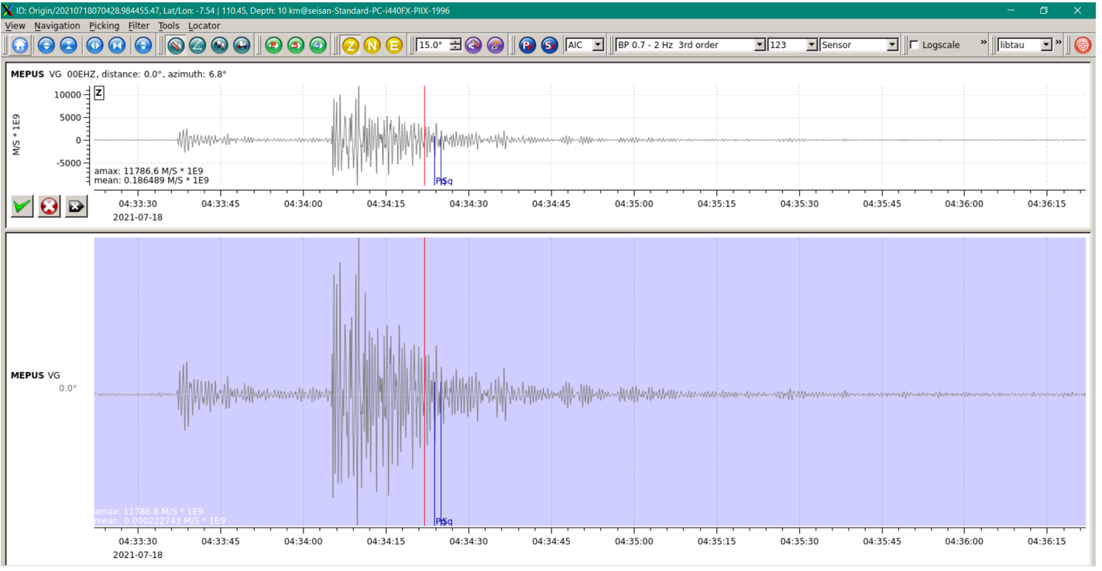

Figure seiscomp instrument corrected waveform from Sulstiani, Amax = 1.17E-05 m/sec

Seisan waveforms

Sulis’ GSE2 response file checks out with hand calculations. The GSE2 response is in DISPLACEMENT, so values of velocity amplitude are (displacement)/(2*pi).

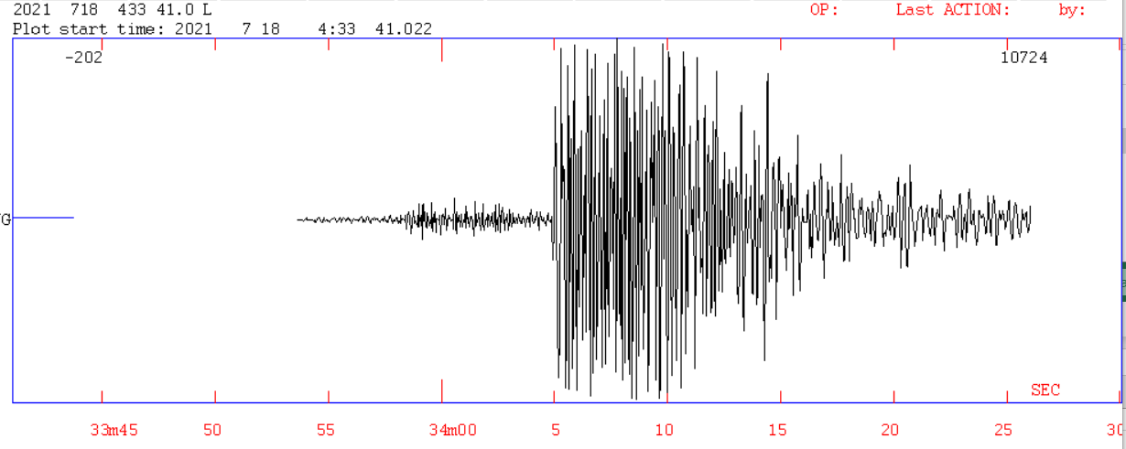

Figure SEISAN plot of PUS. Unfiltered, max amplitude = 10724 cts, average = 202 cts

Figure 2 Uncorrected max amplitude = 10724 cts, or 10724ct/3276.8ct/V = 3.3V

Note: The maximum voltage output of the discriminator should be +/- 2.500V. The 3.3V value indicates a problem with either the discriminator adjustment or the assumption of a +/-10V range for the Guralp ADC. Maybe it’s a +/-5V range, or there’s another gain figure. The waveform appears to be clipped, suggesting a 2.5V maximum value. For a 16-bit, +/-10 range Guralp, a 2.5V input would be 8192ct.

From calculations, amplitude (1hz) = 4.6E+08ct/m/sec

From Figure 2, Approx max velocity, 10724ct / 4.60E+08ct/m/sec ~ 2.3E-05m/sec

Now apply the known good GSE2 response curve to PUS (figure 2)

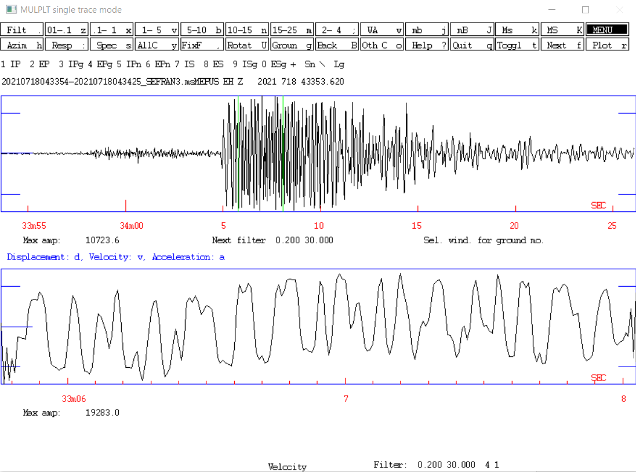

Figure MULPLT window, Station PUS, filtered .2 - 30Hz, GSE response applies, velocity response. ampl = 19283.0nm/sec = 1.93 E-05m/sec

Seisan’s GSE2-corrected velocity response for PUS is 1.93E-05m/sec, compared to seiscomp’s 1.71E-05m/sec amplitude.

These amplitude measurements are very similar. Note that the GSE2-corrected Seisan amplitude values vary, depending on window length and filtering. But the values are pretty close to the 1.71E-05 seiscomp value in figure 1.

# Appendix 1. measuring the fundamental SP seismometer characteristics, Damping (B) and Motor Constant (G)

This procedure is based on Pat McChesney’s explanation of Tony Qamar’s procedure used at The University of Washington Pacific Northwest Seismic Network.

Details and mathematics of the procedure can be found in the supporting documents.

The goal of this procedure is to determine the correct S and T impedance-matching resistors on the McVCO to give an effective motor constant Ge = 100V/m/sec, and a damping constant B= 0.8 or 0.7.

Those are the standard values used by the US Geological Survey.

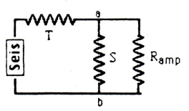

Figure 0: S and T resistors. Ramp is the McVCO input amplifier impedance, 10,000 ohms. Note that on McVCO, T is split between the upper and lower legs of the seismometer input. Therefore on McVCO we use two T resistors, each with half the resistance of the calculated T resistor.

Procedure:

The procedure is to connect a 1.5v battery across the seismometer leads, disconnect the battery and observe the seismic signal decay on an oscilloscope. The procedure is repeater with external resistances (re) of 100k, 50k, 33k and 25k ohms, and the results averaged.

Figure 1 shows the circuit used for calibration.

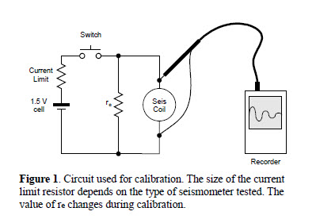

Refer to the excel spreadsheet ‘L4 Puti’ for this discussion:

Every seismometer calibration should use a new copy of the spreadsheet that can be named ‘ L4 (serialNumber_date)’.

**First:**

Read the following values from the seismometer, and enter them into Table 1 on the spreadsheet –

1. Serial number
2. Seismometer mass, M, (kg)
3. Coil resistance, rs (ohms).
4. Case-to-coil resistance
   1. The case to coil resistance should be very large. A low resistance suggests that water is inside the seismometer case.

Note that Ge, (the Effective Motor Constant), Ramp (the McVCO input amplifier impedance), and the desired damping B have already been entered into Table 1. You may change them if necessary, for other VCO models.

Note also that the coil resistance can only be measured if the seismometer is not upright, so that the mass cannot move and generate a current. If the seismometer is buried, you usually cannot measure the coil resistance.

The 6-pin connector on the L4C is as follows:

**Pin color function**

A black coil

B red coil

C green cal coil

D white cal coil

H bare cable shield

Note that the L4 seismometer polarity cannot be determined by the cable color. Some are polarized so that earth motion up causes a positive voltage on the red wire with respect to the black wire. Some L4s have the opposite polarity. Regardless of how the L4 is polarized, you should always wire it to the McVCO so that earth motion up results in a positive-going signal.

**Second:**

Connect the circuit in Figure 1 to the seismometer and oscilloscope.

For the first test, do not connect an external resistor (re). In this case, re is ‘open’ or infinity.

With the oscilloscope, measure A1, A2 and Td. (Note that the value for Td is to be written into Table 1.)

Fill the values into the appropriate cells in the spreadsheet for re = 1,000,000,000 ohms.

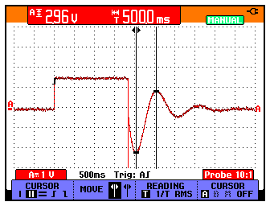

Figure 2. Measure A1.

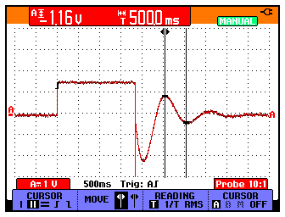

Figure 3. Measure A2.

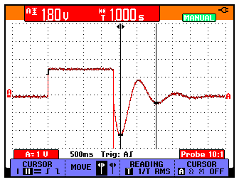

Figure 4. Measure Td.

**Third:** repeat the second step with re = 100k, 50k, 33k, and 35k ohms.

**Quality check:** The values for G (not Ge) should all be similar, regardless of whether re = 100k, 50k, 33k, or 35k ohms. They are usually between 250 and 300.

**Cross-check:**

Now that you have calculated the optimal S and T values, use the cross-check calculator to find out if other, more convenient or pre-existing S and T values will result in acceptable Ge and B values.

Acceptable Ge values are between 98- 102 V/m/sec. Acceptable B values are 0.7 or 0.8. use S and T values to keep Ge and B within these acceptable ranges.

Note that the coil resistance rs can vary a lot due to temperature changes, and charge on the coil itself caused by motion or the small current used in measuring resistance. Because rs is so variable, it is generally not useful to try to calculate S and T based on precise measurement of rs. Instead, we measure rs to check on the condition of the seismometer, and usually use the value of 5500 ohms for rs.

L22-

The procedure for the L22 is similar for the L4. One difference is that there are several models of L22 sensors used in Indonesia with different coil resistances, 210, 325, 510 ohms. Some may have resistances of 5000 ohms.

Also, the L-22E model is already damped to 0.71 and requires no external damping resistors.

# Appendix 2: Seisan Frequency and Phase (FAP) velocity response output, station PUS example

Note that the gain at 1Hz = 4.63E+08

SENSOR TYPE: SEISMOMETER RESPONSE: VELOCITY

SEISMOMETER PERIOD= 1.00000000

GENERATOR CONSTANT= 100.000000

DAMPING RATIO = 0.800000012

AMPLIFIER GAIN(DB)= 67.0999985

RECORDING GAIN= 3276.80005

FILTER CONSTANTS

F= 30.00 POLES= 4

F= 20.00 POLES= 4

GAIN AT 1 HZ= 463799136.

F= 0.0050 T= 200.00 AMP= 0.000040 AMPDB= -88.0 PHAS= -180.5

F= 0.0059 T= 169.49 AMP= 0.000056 AMPDB= -85.1 PHAS= -180.6

F= 0.0070 T= 142.86 AMP= 0.000078 AMPDB= -82.1 PHAS= -180.7

F= 0.0083 T= 120.48 AMP= 0.000110 AMPDB= -79.2 PHAS= -180.9

F= 0.0098 T= 102.04 AMP= 0.000154 AMPDB= -76.3 PHAS= -181.0

F= 0.0120 T= 83.33 AMP= 0.000230 AMPDB= -72.8 PHAS= -181.2

F= 0.0140 T= 71.43 AMP= 0.000314 AMPDB= -70.1 PHAS= -181.5

F= 0.0160 T= 62.50 AMP= 0.000410 AMPDB= -67.8 PHAS= -181.7

F= 0.0190 T= 52.63 AMP= 0.000578 AMPDB= -64.8 PHAS= -182.0

F= 0.0230 T= 43.48 AMP= 0.000846 AMPDB= -61.4 PHAS= -182.4

F= 0.0270 T= 37.04 AMP= 0.001166 AMPDB= -58.7 PHAS= -182.8

F= 0.0320 T= 31.25 AMP= 0.001638 AMPDB= -55.7 PHAS= -183.3

F= 0.0370 T= 27.03 AMP= 0.002190 AMPDB= -53.2 PHAS= -183.9

F= 0.0440 T= 22.73 AMP= 0.003096 AMPDB= -50.2 PHAS= -184.6

F= 0.0520 T= 19.23 AMP= 0.004323 AMPDB= -47.3 PHAS= -185.4

F= 0.0620 T= 16.13 AMP= 0.006144 AMPDB= -44.2 PHAS= -186.5

F= 0.0730 T= 13.70 AMP= 0.008514 AMPDB= -41.4 PHAS= -187.6

F= 0.0870 T= 11.49 AMP= 0.012084 AMPDB= -38.4 PHAS= -189.1

F= 0.1000 T= 10.00 AMP= 0.015955 AMPDB= -35.9 PHAS= -190.4

F= 0.1200 T= 8.33 AMP= 0.022945 AMPDB= -32.8 PHAS= -192.5

F= 0.1400 T= 7.14 AMP= 0.031183 AMPDB= -30.1 PHAS= -194.6

F= 0.1700 T= 5.88 AMP= 0.045851 AMPDB= -26.8 PHAS= -197.8

F= 0.2000 T= 5.00 AMP= 0.063246 AMPDB= -24.0 PHAS= -200.9

F= 0.2400 T= 4.17 AMP= 0.090563 AMPDB= -20.9 PHAS= -205.2

F= 0.2800 T= 3.57 AMP= 0.122414 AMPDB= -18.2 PHAS= -209.4

F= 0.3300 T= 3.03 AMP= 0.168221 AMPDB= -15.5 PHAS= -214.8

F= 0.3900 T= 2.56 AMP= 0.231163 AMPDB= -12.7 PHAS= -221.2

F= 0.4600 T= 2.17 AMP= 0.313903 AMPDB= -10.1 PHAS= -228.8

F= 0.5500 T= 1.82 AMP= 0.431026 AMPDB= -7.3 PHAS= -238.5

F= 0.6500 T= 1.54 AMP= 0.568267 AMPDB= -4.9 PHAS= -249.1

F= 0.7700 T= 1.30 AMP= 0.731119 AMPDB= -2.7 PHAS= -261.3

F= 0.9100 T= 1.10 AMP= 0.903723 AMPDB= -0.9 PHAS= 85.4

F= 1.1000 T= 0.91 AMP= 1.092252 AMPDB= 0.8 PHAS= 69.5

F= 1.3000 T= 0.77 AMP= 1.233880 AMPDB= 1.8 PHAS= 55.4

F= 1.5000 T= 0.67 AMP= 1.330371 AMPDB= 2.5 PHAS= 43.8

F= 1.8000 T= 0.56 AMP= 1.420834 AMPDB= 3.1 PHAS= 29.6

F= 2.1000 T= 0.48 AMP= 1.473917 AMPDB= 3.4 PHAS= 18.3

F= 2.5000 T= 0.40 AMP= 1.515108 AMPDB= 3.6 PHAS= 6.1

F= 2.9000 T= 0.34 AMP= 1.539083 AMPDB= 3.7 PHAS= -4.2

F= 3.5000 T= 0.29 AMP= 1.559674 AMPDB= 3.9 PHAS= -17.4

F= 4.1000 T= 0.24 AMP= 1.571306 AMPDB= 3.9 PHAS= -28.9

F= 4.9000 T= 0.20 AMP= 1.580311 AMPDB= 4.0 PHAS= -42.7

F= 5.8000 T= 0.17 AMP= 1.586116 AMPDB= 4.0 PHAS= -57.2

F= 6.8000 T= 0.15 AMP= 1.589883 AMPDB= 4.0 PHAS= -72.4

F= 8.1000 T= 0.12 AMP= 1.592432 AMPDB= 4.0 PHAS= -91.7

F= 9.5000 T= 0.11 AMP= 1.592818 AMPDB= 4.0 PHAS= -112.2

F= 11.0000 T= 0.09 AMP= 1.589354 AMPDB= 4.0 PHAS= -134.3

F= 13.0000 T= 0.08 AMP= 1.571494 AMPDB= 3.9 PHAS= -164.8

F= 16.0000 T= 0.06 AMP= 1.474164 AMPDB= 3.4 PHAS= -213.8

F= 19.0000 T= 0.05 AMP= 1.223858 AMPDB= 1.8 PHAS= -266.2

F= 22.0000 T= 0.05 AMP= 0.866388 AMPDB= -1.2 PHAS= 42.6

F= 26.0000 T= 0.04 AMP= 0.460310 AMPDB= -6.7 PHAS= -17.8

F= 31.0000 T= 0.03 AMP= 0.180047 AMPDB= -14.9 PHAS= -79.8

F= 37.0000 T= 0.03 AMP= 0.053983 AMPDB= -25.4 PHAS= -134.3

F= 43.0000 T= 0.02 AMP= 0.017242 AMPDB= -35.3 PHAS= -171.4

F= 51.0000 T= 0.02 AMP= 0.004497 AMPDB= -46.9 PHAS= -204.6

F= 60.0000 T= 0.02 AMP= 0.001232 AMPDB= -58.2 PHAS= -229.8

F= 71.0000 T= 0.01 AMP= 0.000321 AMPDB= -69.9 PHAS= -251.0

F= 85.0000 T= 0.01 AMP= 0.000076 AMPDB= -82.4 PHAS= -269.6

F=100.0000 T= 0.01 AMP= 0.000021 AMPDB= -93.7 PHAS= 76.5

# Appendix 3: Seisan Frequency and Phase (FAP) Displacement response output, station PUS example

Gain at 1Hz = 2.91E+09, or 2*π*4.63E+08.

SENSOR TYPE: SEISMOMETER RESPONSE: DISPLACEMENT

SEISMOMETER PERIOD= 1.00000000

GENERATOR CONSTANT= 100.000000

DAMPING RATIO = 0.800000012

AMPLIFIER GAIN(DB)= 67.0999985

RECORDING GAIN= 3276.80005

FILTER CONSTANTS

F= 30.00 POLES= 4

F= 20.00 POLES= 4

GAIN AT 1 HZ= 2.91413606E+09

F= 0.0050 T= 200.00 AMP= 0.000000 AMPDB=-134.0 PHAS= -90.5

F= 0.0059 T= 169.49 AMP= 0.000000 AMPDB=-129.7 PHAS= -90.6

F= 0.0070 T= 142.86 AMP= 0.000001 AMPDB=-125.2 PHAS= -90.7

F= 0.0083 T= 120.48 AMP= 0.000001 AMPDB=-120.8 PHAS= -90.9

F= 0.0098 T= 102.04 AMP= 0.000002 AMPDB=-116.4 PHAS= -91.0

F= 0.0120 T= 83.33 AMP= 0.000003 AMPDB=-111.2 PHAS= -91.2

F= 0.0140 T= 71.43 AMP= 0.000004 AMPDB=-107.2 PHAS= -91.5

F= 0.0160 T= 62.50 AMP= 0.000007 AMPDB=-103.7 PHAS= -91.7

F= 0.0190 T= 52.63 AMP= 0.000011 AMPDB= -99.2 PHAS= -92.0

F= 0.0230 T= 43.48 AMP= 0.000019 AMPDB= -94.2 PHAS= -92.4

F= 0.0270 T= 37.04 AMP= 0.000031 AMPDB= -90.0 PHAS= -92.8

F= 0.0320 T= 31.25 AMP= 0.000052 AMPDB= -85.6 PHAS= -93.3

F= 0.0370 T= 27.03 AMP= 0.000081 AMPDB= -81.8 PHAS= -93.9

F= 0.0440 T= 22.73 AMP= 0.000136 AMPDB= -77.3 PHAS= -94.6

F= 0.0520 T= 19.23 AMP= 0.000225 AMPDB= -73.0 PHAS= -95.4

F= 0.0620 T= 16.13 AMP= 0.000381 AMPDB= -68.4 PHAS= -96.5

F= 0.0730 T= 13.70 AMP= 0.000621 AMPDB= -64.1 PHAS= -97.6

F= 0.0870 T= 11.49 AMP= 0.001051 AMPDB= -59.6 PHAS= -99.1

F= 0.1000 T= 10.00 AMP= 0.001595 AMPDB= -55.9 PHAS= -100.4

F= 0.1200 T= 8.33 AMP= 0.002753 AMPDB= -51.2 PHAS= -102.5

F= 0.1400 T= 7.14 AMP= 0.004366 AMPDB= -47.2 PHAS= -104.6

F= 0.1700 T= 5.88 AMP= 0.007795 AMPDB= -42.2 PHAS= -107.8

F= 0.2000 T= 5.00 AMP= 0.012649 AMPDB= -38.0 PHAS= -110.9

F= 0.2400 T= 4.17 AMP= 0.021735 AMPDB= -33.3 PHAS= -115.2

F= 0.2800 T= 3.57 AMP= 0.034276 AMPDB= -29.3 PHAS= -119.4

F= 0.3300 T= 3.03 AMP= 0.055513 AMPDB= -25.1 PHAS= -124.8

F= 0.3900 T= 2.56 AMP= 0.090154 AMPDB= -20.9 PHAS= -131.2

F= 0.4600 T= 2.17 AMP= 0.144395 AMPDB= -16.8 PHAS= -138.8

F= 0.5500 T= 1.82 AMP= 0.237065 AMPDB= -12.5 PHAS= -148.5

F= 0.6500 T= 1.54 AMP= 0.369373 AMPDB= -8.7 PHAS= -159.1

F= 0.7700 T= 1.30 AMP= 0.562961 AMPDB= -5.0 PHAS= -171.3

F= 0.9100 T= 1.10 AMP= 0.822388 AMPDB= -1.7 PHAS= 175.4

F= 1.1000 T= 0.91 AMP= 1.201478 AMPDB= 1.6 PHAS= 159.5

F= 1.3000 T= 0.77 AMP= 1.604044 AMPDB= 4.1 PHAS= 145.4

F= 1.5000 T= 0.67 AMP= 1.995556 AMPDB= 6.0 PHAS= 133.8

F= 1.8000 T= 0.56 AMP= 2.557501 AMPDB= 8.2 PHAS= 119.6

F= 2.1000 T= 0.48 AMP= 3.095225 AMPDB= 9.8 PHAS= 108.3

F= 2.5000 T= 0.40 AMP= 3.787770 AMPDB= 11.6 PHAS= 96.1

F= 2.9000 T= 0.34 AMP= 4.463341 AMPDB= 13.0 PHAS= 85.8

F= 3.5000 T= 0.29 AMP= 5.458858 AMPDB= 14.7 PHAS= 72.6

F= 4.1000 T= 0.24 AMP= 6.442354 AMPDB= 16.2 PHAS= 61.1

F= 4.9000 T= 0.20 AMP= 7.743526 AMPDB= 17.8 PHAS= 47.3

F= 5.8000 T= 0.17 AMP= 9.199471 AMPDB= 19.3 PHAS= 32.8

F= 6.8000 T= 0.15 AMP= 10.811206 AMPDB= 20.7 PHAS= 17.6

F= 8.1000 T= 0.12 AMP= 12.898704 AMPDB= 22.2 PHAS= -1.7

F= 9.5000 T= 0.11 AMP= 15.131771 AMPDB= 23.6 PHAS= -22.2

F= 11.0000 T= 0.09 AMP= 17.482899 AMPDB= 24.9 PHAS= -44.3